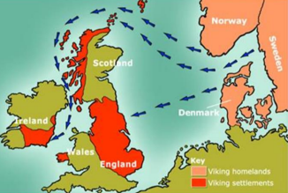

**Lindisfarne**

The Vikings first attacked England at Lindisfarne Monastery in 793AD. The Vikings were pagans, not Christians like most people living in England at the time. The monasteries were easy targets for the Vikings because the monks had no weapons and the buildings were filled with valuable treasures like gold, jewels and books.

